Work with your literature circle group to list the main events in *The BFG* by Roald Dahl. Talk to each other about the events that make up the rising action, the climax, and the falling action. Take notes and be sure to agree on the list of events that should be included as MAIN EVENTS.

Work independently to use this information to create a plot diagram of the novel. Be sure your diagram uses a visual representation of the rising action, climax, and falling action. Event descriptions should be brief but allow someone who has read the novel to readily understand the event in question. Your diagram must meet all of the criteria listed below.

5 points each:

Diagram includes between ten and twenty MAIN EVENTS, which are accurate to the story

Events are arranged in the order in which they occur

Events are arranged on a visual representation of rising action, climax, and falling action

Event descriptions are brief and clear

Viewer of diagram sees a quick overview of entire novel

Event descriptions use proper spelling, grammar, and capitalization

Presentation is neat and easy to understand

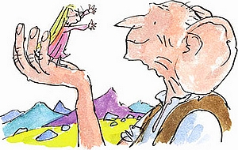

points earned %

35 points possible