**Ch. 9 Review**

**Write the correct answer in the blank at the right of each question.**

**1.** Find the area of the parallelogram.

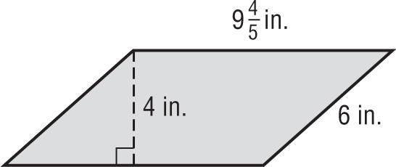

**2.** Find the base of a parallelogram with height 11.8 millimeters and an area of 151.04 square millimeters.

**3.** A triangular logo that is painted on the side of a building has a base length of 8 feet and a height of 4 yards. What is the area of the logo in square feet?

**4.** A triangle has a base of 35 centimeters and an area of 819 square centimeters. What is the height of the triangle?

**5.** The figure at the right shows the approximate dimensions of Clare County.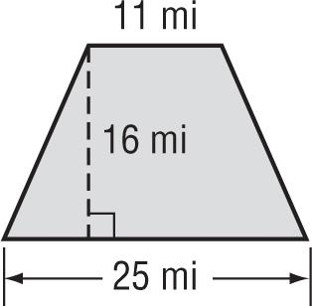

What is the area of Clare County?

**6.** Suppose the base and height of the parallelogram in Exercise 1 is multiplied by 3. What effect would this have on the area of the parallelogram? Explain your reasoning.

**7.** The side lengths of a triangle are 3 meters, 4 meters, and 5 meters. Suppose the side lengths are multiplied by 4. Describe the change in the perimeter.

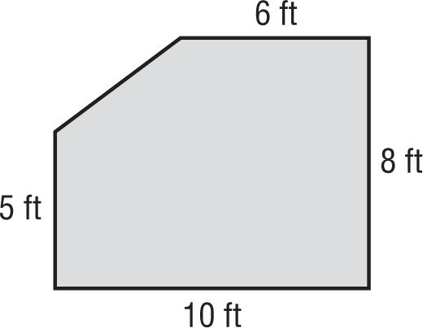

**8.** The figure at the right shows the dimensions of the garden in Marissa’s back yard. What is the area of the garden?

**9.** A figure has vertices at *A*(1, 2), *B*(2, 6), *C*(4, 6), and *D*(6, 2). Graph the figure and classify it. Then find the area.

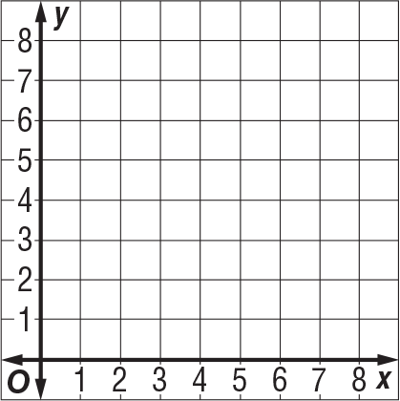

**10.** A rectangle has vertices *W*(2, 3), *X*(2, 6), *Y*(7, 6), and *Z*(7, 3). Describe how to find the side lengths of the rectangle without graphing.