**Chapter 9 Mid-Chapter Test** SCORE ___________

*(Lessons 9-1 through 9-5)*

**Part I *Write the letter for the correct answer in the blank at the right of each question.***

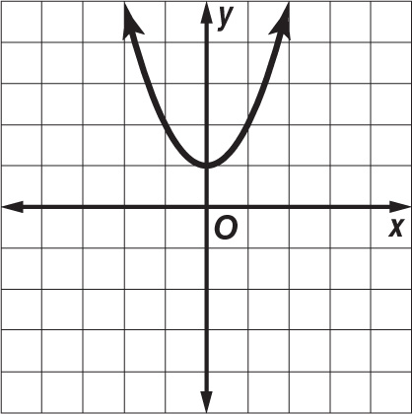 **1.** Which equation corresponds to the graph shown?

**A** *y* = $x^{2}$– 1 **C** *y* = $x^{2}$ + 1

**B** *y* = $-{(x-1)}^{2}$**D** *y* = $-{(x+1)}^{2}$

**2.** Find the coordinates of the vertex of the graph of

*y* = $x^{2}$– 8*x* + 10. Identify the vertex as a maximum

or a minimum.

**F** (4, –6); minimum **H** (4, 6); maximum

**G** (–4, 58); maximum **J** (–4, 26); minimum

**3.** Solve $x^{2}$– 24*x* + 144 = 36 by taking the square root of each side.

**A** –6, 18 **B** 6, 18 **C** 6, 12 **D** –6, 6

**4.** Which equation can be used to solve 5 $b^{2}$ + 30*b* – 10 = 0 by completing the square?

**F ${(b+6)}^{2}$**  = 38 **G ${(b+6)}^{2}$**  = 46 **H ${(b+3)}^{2}$**  = 11 **J ${(b+3)}^{2}$**  = 19

**5.** Which step is *not* performed in the process of solving $r^{2}$ + 8*r* + 5 = 0 by completing   
the square?

**A** Subtract 5 from each side. **C** Add 16 to each side.

**B** Factor $r^{2}$ + 8*r*. **D** Take the square root of each side.

**Part II**

**Solve each equation by graphing. If integral roots cannot be found, estimate the roots to the nearest tenth.**

**6. $x^{2}$**  – 7*x* – 8 = 0

**7. $x^{2}$**  + 1 = 5*x*

**For Questions 8 and 9, round to the nearest tenth if necessary.**

**8.** Solve $x^{2}$ + 4*x* = 20 by completing the square.

**9.** Solve –2 $x^{2}$ + 18 = 7*x* by using the Quadratic Formula.

**10.** The base of a rectangle is 4 more than the height. The area of the rectangle is 15 square inches. What are the dimensions of the rectangle to the nearest tenth of an inch?

**1.** ________________

**2.** ________________

**3.** ________________

**4.** ________________

**5.** ________________

**6.** ________________

**7.** ________________

**8.** ________________

**9.** ________________

**10**. ________________